MAP REDUCE

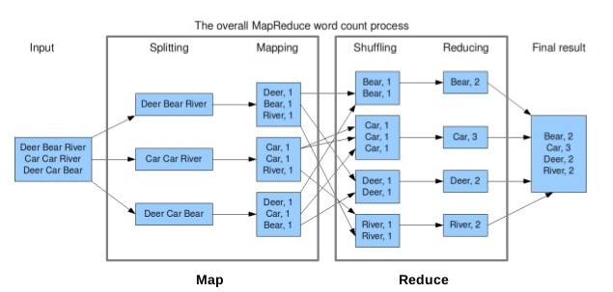

DATA STORAGE AND RETRIEVAL OPTIONS

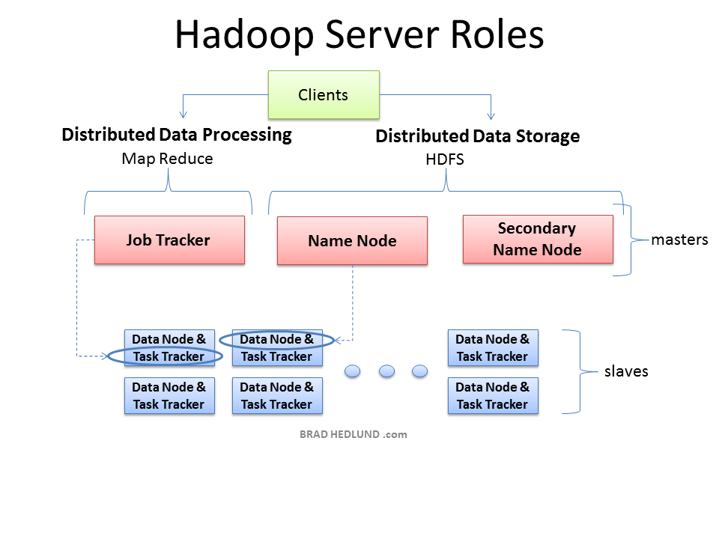

BATCH PROCESSING OPERATIONS

